**Bug report**

[Sort][Dropdown][Throbber]**User can’t sort items on the page by picking ‘sort by’ option from the dropdown list**

**Description**

When user clicks on the “Woman” tab on the homepage and then, when redirected to the “Woman” page, scrolls down to the “Sort by” dropdown list and tries to sort clothes items that are seen below, the dropdown list throbber is seen on the center of the screen and it wouldn’t stop spinning. Also,the clothes items below are not sorted. It is the same for every category in the dropdown list menu the user tries to choose.

**Steps**

1. Open Chrome browser
2. Go to the following URL:<http://automationpractice.com/index.php>
3. Click on “Women” tab on the left side of the screen
4. Scroll down and after the content of the subtitle “Subcategories” on the right side of the page there will be dropdown list with the label “Sort by”
5. Click on the dropdown list with the label “Sort by”
6. Choose one of the options(example:Product name A to Z)
7. Click on “Refresh” button on the Chrome browser
8. Scroll down and after the content of the subtitle “Subcategories” on the right side of the page there will be dropdown list with the label “Sort by”
9. Click on the dropdown list with the label “Sort by”
10. Choose one of the options(example:Product name Z to A)

**Expected result:** Products below the dropdown list were sorted by the chosen category.

**Actual result :** Throbber is seen on the screen, wouldn’t stop spinning and wouldn’t proceed to a sorted items list.

**Screehshot**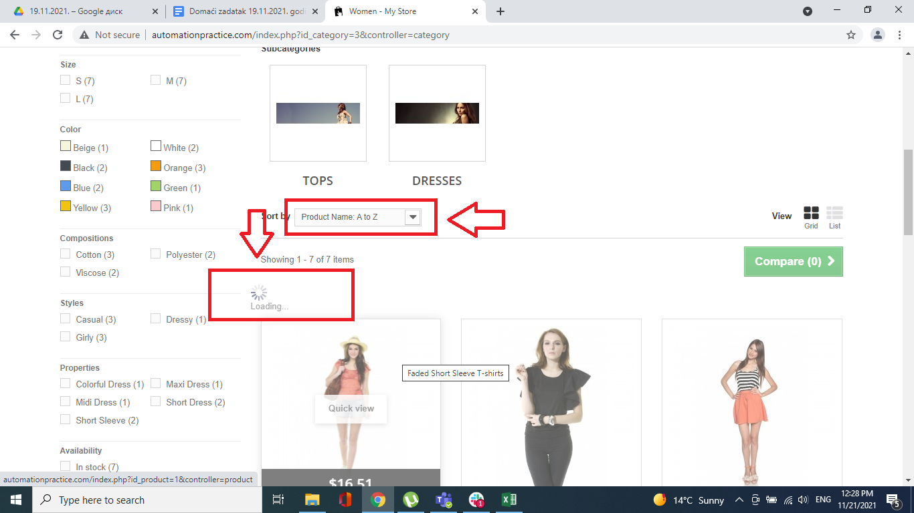

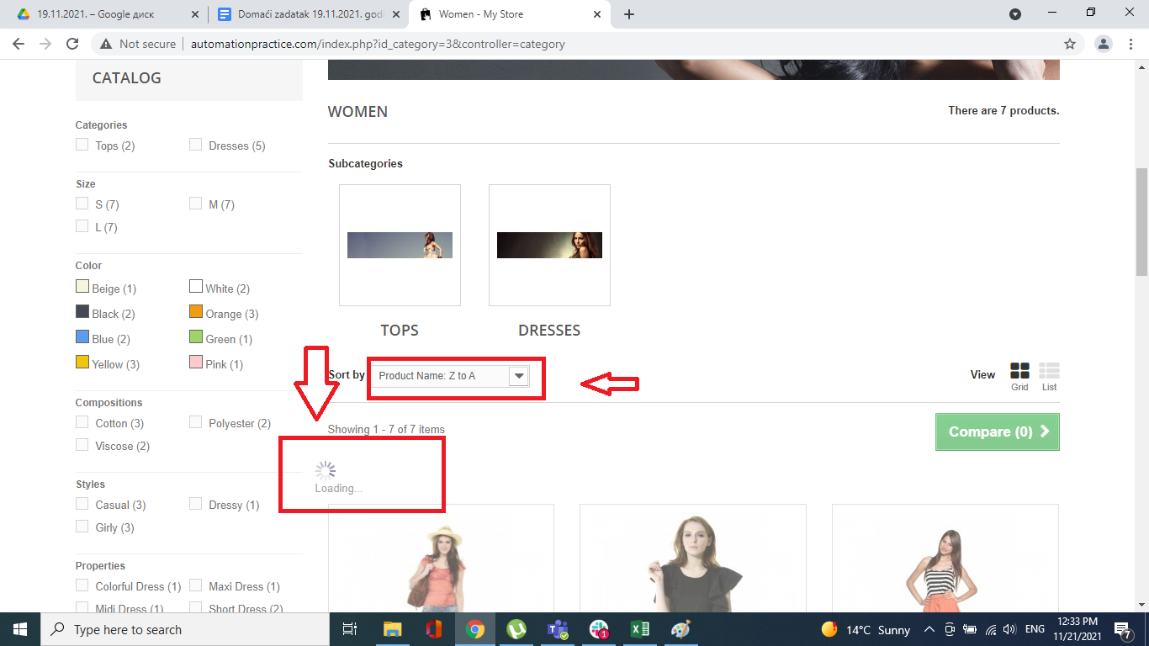

**Priority:** Low

**Severity:** Low

**Repro rate:** 100%